Nama : Amaliyah Gian F

NIM : 18090085

Kelas : 5A

Laporan Praktikum 6

1. Source Code

autoload.php 🡪 application/config/

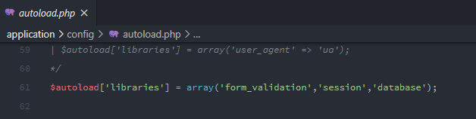

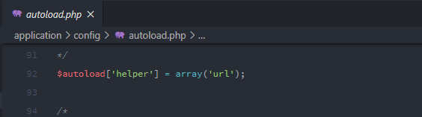

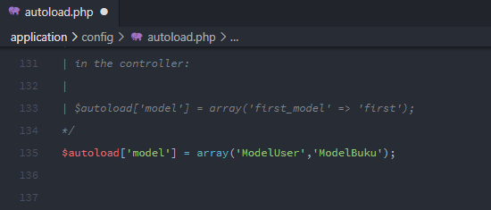

database.php 🡪 application/config/

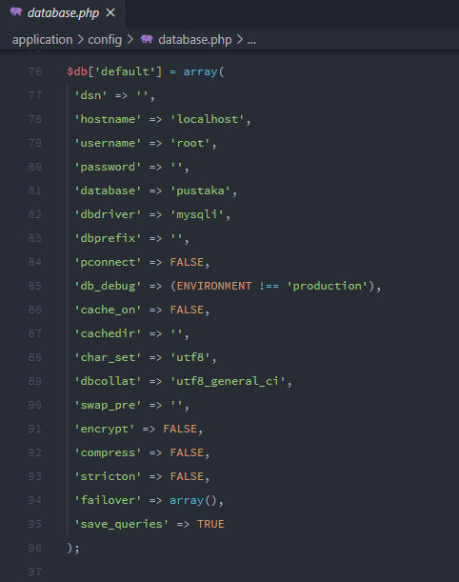

ModelUser.php 🡪 application/models/

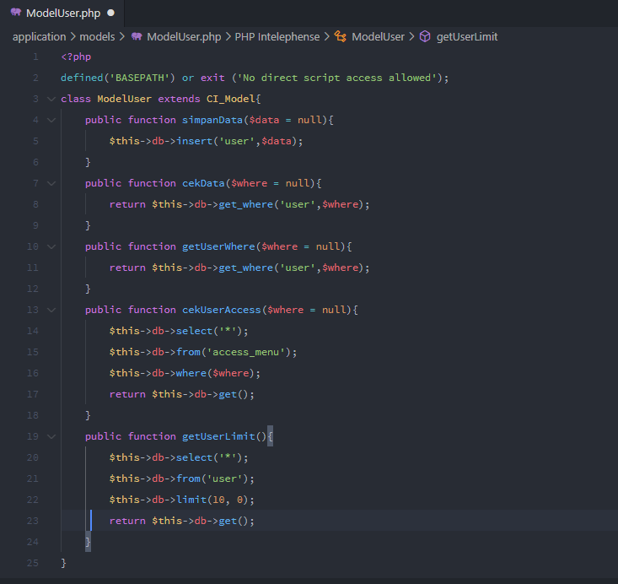

ModelBuku.php 🡪 application/models/

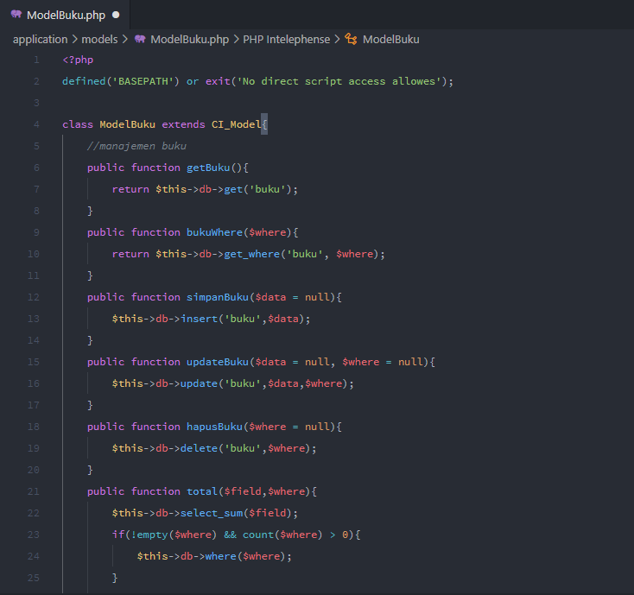

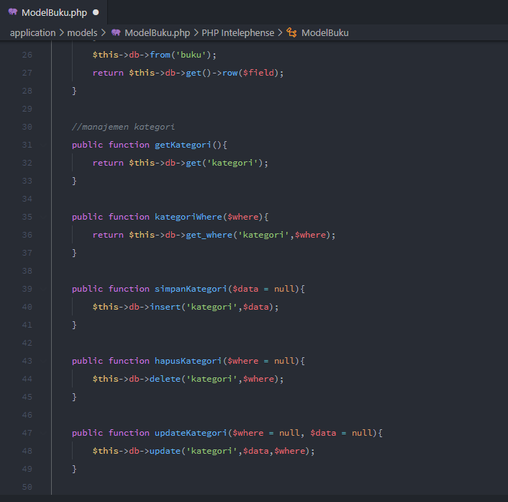

1. Membuat Database Pustaka

* Table user

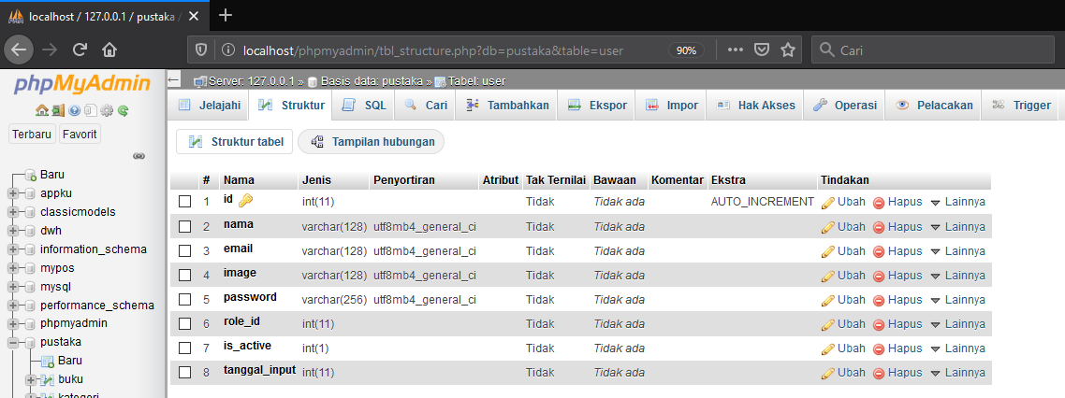

* Table buku

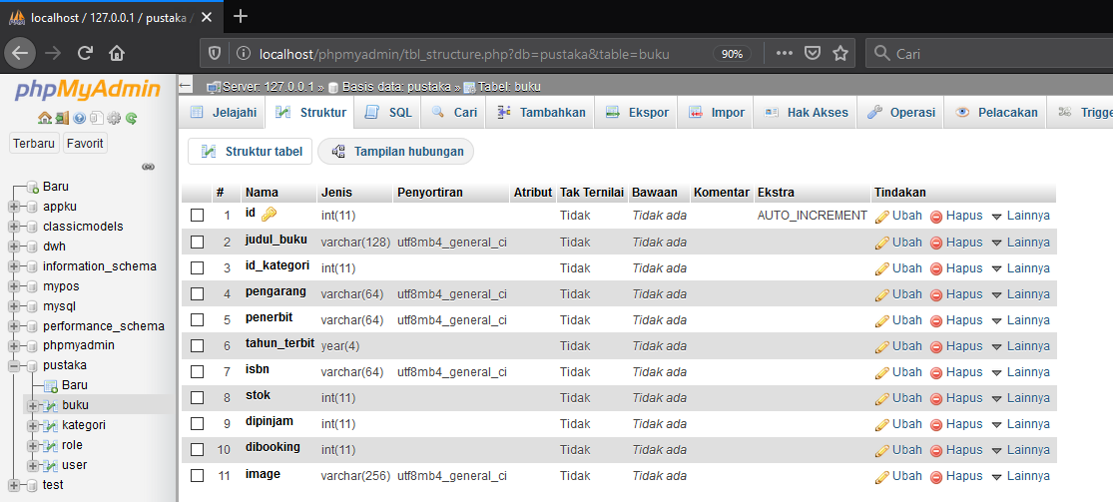

* Table role

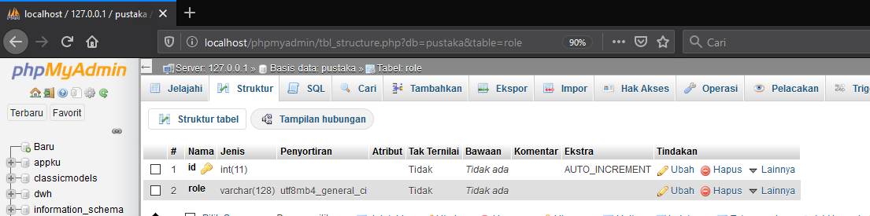

* Table kategori

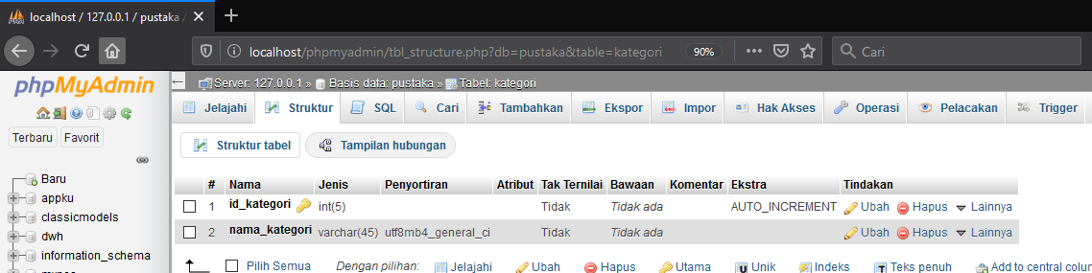

1. Capture

